Chapter 2 Specification Requirement

2.1 Use Case Scenario

2.1.1 Feature 1

2.1.1.1 Actor
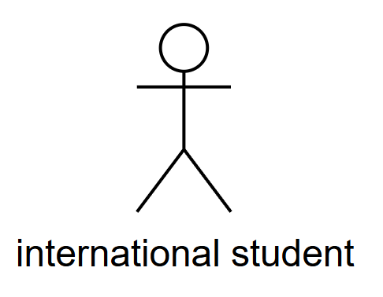

2.1.1.2 Use Case Diagram
Feature 1: Daily Briefing System
Feature 1 enables International Student to obtain Thai news through the Daily Briefing System. Use case UC‑01 “Browse Daily Briefing” lets International Student open the Daily Briefing page and receive a list of recent news summaries that have been aggregated and translated from approved Thai official and media sources. Use case UC‑02 “View News Details” allows International Student to select one Daily Briefing item and open a detail view containing bilingual title, bilingual summary, source, publication date, crawl time and a clearly labeled original link. Use case UC‑03 “Search News” provides keyword‑based retrieval over titles and summaries in both Chinese and English within the Daily Briefing dataset, while use case UC‑05 “Filter News” lets International Student narrow the same dataset using structured criteria such as date range and news source. Use case UC‑04 “Jump to Original Link” supports direct navigation from a Daily Briefing item or detail view to the full article on the external official website in a new browser tab. Use case UC‑06 “Switch Interface Language” allows International Student to toggle between Chinese and English interfaces, after which the Daily Briefing System selects the corresponding translated fields for every news item and remembers the language preference in a cookie for subsequent visits.
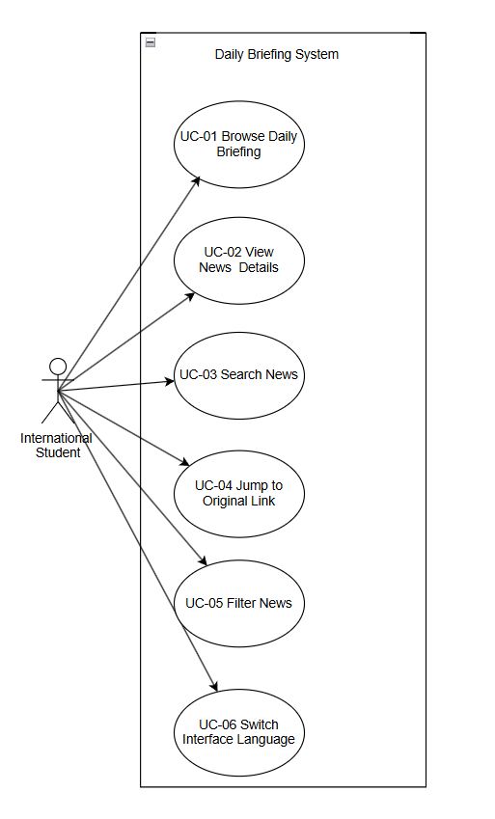

2.1.2 Feature2

2.1.2.1 Actor


2.1.2.2 Use Case Diagram
Feature 2: Community
Feature 2 provides a community space where International Student can publish and interact with bilingual posts. Use case UC‑07 “Browse Community Feed” delivers a continuously updated feed of community posts authored by International Student, displaying bilingual titles, previews, engagement metrics and moderation status. Use case UC‑08 “Create/Edit/Publish Post” enables International Student to create new posts or modify existing posts in Chinese or English, invoke AI‑based translation and moderation, and publish the posts to the community once the posts satisfy safety rules. Use case UC‑11 “View Post Details” supports opening a single community post with full bilingual content, images, author information. Use case UC‑09 “Like Post” lets International Student express positive feedback on a specific post and updates the like counter in a controlled way. Use case UC‑10 “Filter by Tag” allows International Student to focus on posts belonging to specific topics by selecting tags. Use case UC‑13 “Post Comment” enables International Student to add bilingual comments under a post, while use case UC‑12 “Report Post/Comment” allows International Student to send structured reports about suspected spam, fraud or abuse on individual posts or comments for later moderation. Use case UC‑14 “Search Posts” offers full‑text search across bilingual post titles and bodies, combined with active tag filters, and returns a ranked community feed containing only posts that satisfy the query.
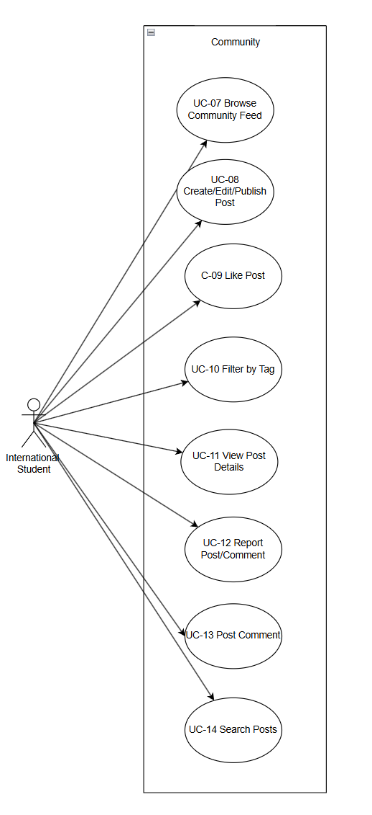

2.2.3 Feature 3

2.2.3.1 Actor

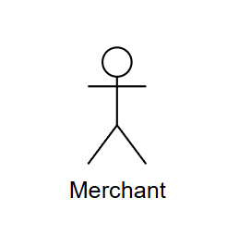

2.2.3.2 Use Case Diagram
Feature 3: Marketplace – Buy & Sell
Feature 3 supports buy‑and‑sell interactions between International Student and Merchant through a structured Marketplace. Use case UC‑15 “Search and Filter Post” provides keyword search and multi‑criteria filtering over all marketplace posts based on category, price range and listing type, and returns a paginated result list that only contains listings meeting the specified conditions.Use case UC‑16 “View Buy/Sell Information Post” displays a posts of marketplace, where each posts represents a supply or demand post shows titles, short descriptions, prices, thumbnails. Use case UC‑17 “View Buy/Sell Information Post Details” allows International Student and Merchant to open an individual post, inspect descriptions and contact information, and decide on further actions such as following the seller or initiating communication. Use case UC‑18 “Follow Account” lets International Student and Merchant subscribe to other accounts , establishes follower–followee relationships for later notification and messaging, and marks mutual‑follow relationships to chat when both sides follow each other. Use case UC‑19 “Post Buy/Sell Information Post” enables International Student and Merchant to create structured listings in Chinese or English by submitting category, description, price, goods photos, after which the Marketplace System runs AI translation and moderation, stores all language versions and publishes the posts according to review results.
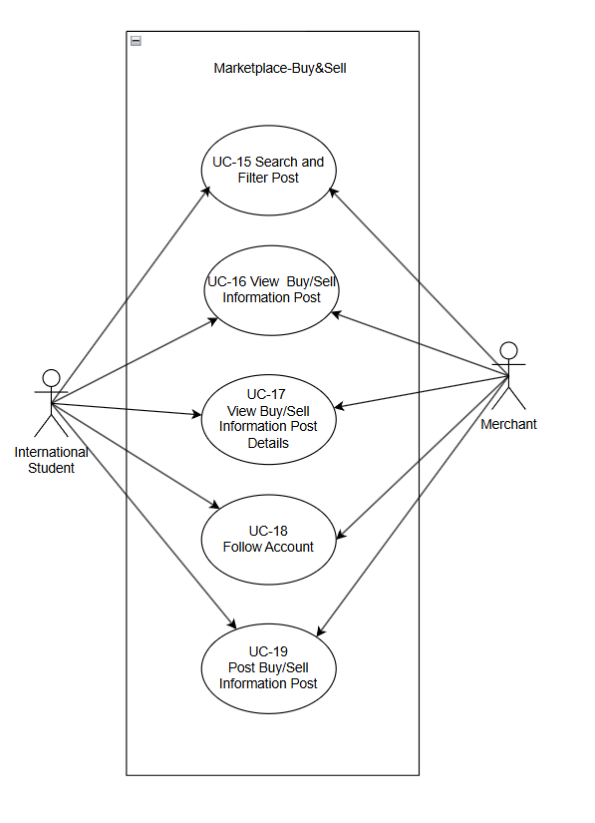

2.2.4 Feature 4

2.2.4.1 Actor



2.2.4.2 Use Case Diagram
Feature 4: Message
Feature 4 delivers private communication and relationship management based on mutual follows. Use case UC‑22 “View and Manage the Mutual Follow List” enables International Student and Merchant, to see a list of accounts that have established bidirectional follow relationships with the current account, and to open profiles, remove follows or start conversations from this list. Use case UC‑20 “Communicate with Others (merchants/international students)” allows User to open an existing conversation or create a new conversation with a mutual‑follow partner, send and receive text or media messages that the Message System stores with timestamps and read states, and view the conversation history in a chat interface. Use case UC‑21 “Manage Message (read/unread/delete)” lets User received and sent messages by marking messages as read ,,It is also possible to delete the entire conversation record
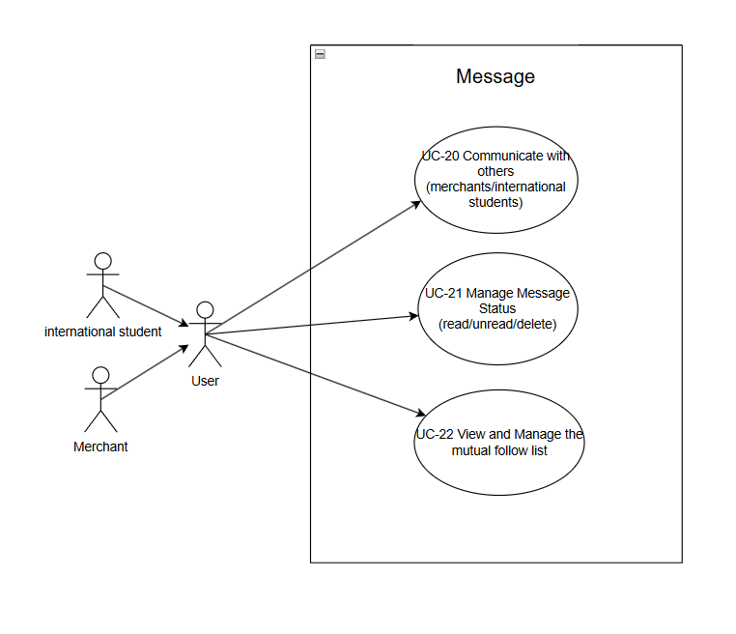

2.2.5 Feature 5

2.2.5.1 Actor




2.2.5.2 Use Case Diagram
Feature 5: Profile
Feature 5 offers profile views that connect account information with personal content . Use case UC‑23 “View/Edit Profile” allows International Student and Merchant to open the profile page, review stored information such as display name, avatar, preferred language and contact channels, and submit edits that the Profile System validates and saves back to the user database. Use case UC‑24 “View My Community Posts” provides International Student and Merchant with a dedicated list of community posts authored by the current account, including each post’s publication time and moderation status. Use case UC‑25 “View My Marketplace Post” shows International Student and Merchant all marketplace posts created by the current account.

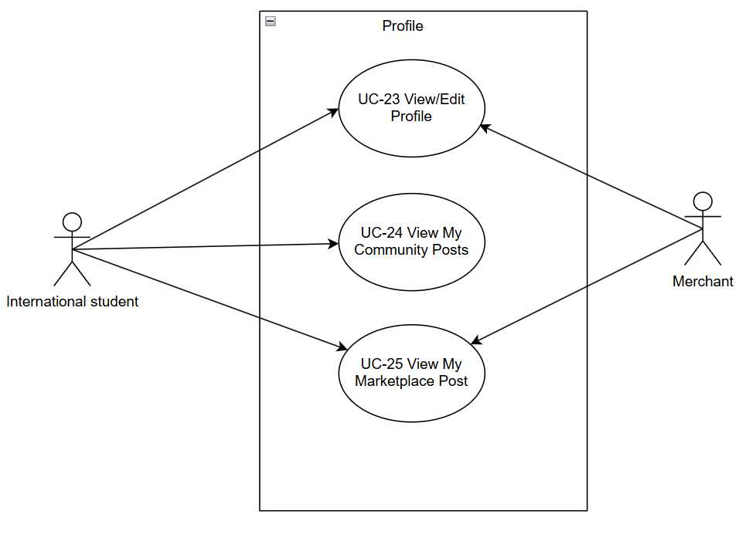

2.2 User Requirement Specification
Feature 1:
URS-01 - Browse daily briefings/definitions
Users (international students or businesspeople) can open the Daily Briefing page to view Daily Briefing. Daily Briefing is defined as a paginated list of recent news items captured by the system from approved Thai official and media websites, translated into Chinese and English, and stored in the news database. And present it in the form of a news summary.
URS -02 - View news details
When the user selects the Daily Briefing entry, the system will display the News Detail view, which shows the title, summary, news source name and original article URL of the entry in the user's current interface language.
URS -03 - Search for News
Users can enter Chinese or English keywords in the search box to search and receive news that meets the search criteria.
URS-04 - Filtering News
When browsing, users can filter The Daily Briefing by specifying structured criteria, including at least one date range (start date and end date) and one or more news sources (such as Bangkok Post, The Nation Thailand); The system applies these conditions to news queries and only returns Daily Briefing items that satisfy all selected filters.
URS-05 - Jump to the original link
When the user clicks the "Jump to Original Link" function in the Daily Briefing card or the News Detail view, the system will open the original URL corresponding to the approved source website in a new browser TAB.
URS-06 - Switch Interface Language
Users can switch the interface language between Chinese and English at any time. The system will reload all interface text and select the corresponding Chinese or English translation fields for each news headline and summary.

Feature 2:
Feature 2 - Community (English)
URS-07 - Browse the community feed
International students can open the community page and browse the posts made by users within the community
-URS-08 - Create/Edit/Publish community posts
International students can create new community posts or edit existing ones by submitting content fields in either Chinese or English, such as titles, body text, images and tags.
URS-09 - Like posts
International students can click the “like” button to expression he like this post.
URS-10 - Filter by label
International students can filter posts in the community by selecting tags such as "study", etc.
URS-11 - View posts Details
International students can view the complete details of community posts by selecting one on the community page.
URS-12 - Report Post/Comment
International students can report suspicious spam, fraud, illegal service promotion or abusive language in specific community posts or comments by choosing one or more predefined reasons for reporting and entering text.
URS-13 -Post Comment
International students can post comments under the selected community posts, enter the comment text in either Chinese or English and submit their comments.
URS-14 - Search posts
International students can search for community posts by entering keywords and submitting search requests.

Feature 3:
URS-15 - Search and filter market posts
Users (international students or business people) can search for Marketplace posts by entering structured keyword filters.
URS-16 - View Buy/Sell Information Post
Users (international students or merchants) can open the Marketplace page to view Marketplace posts
URS-17 - View Buy/Sell Information Post Details
Users (international students or business people) can view the complete and detailed information of a specific market post by selecting it from the market list or search results
URS-18 - Follow Account
Users (international students or businesspeople) can follow another account (international students or businesspeople) from market posts or personal profile pages.
URS-19 - Post Buy/Sell Information Post
Users (international students or merchants) can create new Marketplace posts by submitting posts about buying and selling goods in either Chinese or English, including at least the title, description, and price

Feature 4:
URS-20 - Communicate with others (merchants/international students)
Users (international students or Merchant) can communicate with any account on the mutual follow list

URS-21 - Manage Message Status (read/unread/delete)
Users (international students or business people) can mark the messages in the conversation as read, unread or delete this session

URS-22 - View and Manage the mutual follow list
Users (international students or businesses) can open the mutual follow list page to manage their relationships (unfollow, delete user accounts, search and add accounts).

Feature 5:
URS-23 - View and Edit profile
Users (international students or merchants) can open the personal profile page to view and edit their personal account information, including name, profile picture, brief introduction and contact channels (such as phone number, email or social media accounts).
-URS-24 - View my community posts
Users (international students or Merchant can view a dedicated list of community posts written by their current accounts; Users can open the "My Community Posts" section under the "Personal Profile" module. A paginated list will be displayed, where each post at least shows the post title, post content, creation time, and current review status (such as published, pending review, rejected).
URS-25 – View my market posts
Users (international students or Merchant can view a dedicated list of Marketplace posts (lists) created by their current accounts. When a user opens the "My Marketplace Posts" section under the Profile module, a paginated list will be displayed, in which each post shows at least the post title, post content, creation time, and current review status (such as published, pending review, rejected).

